**Modelling and Texturing Vanity Items**

The vanity items are already being built as low poly due to the small scale of the models when they have been placed on the planet, many details would be missed as such the goal of the textures is to allude to what the object looks like but not to convey every detail.

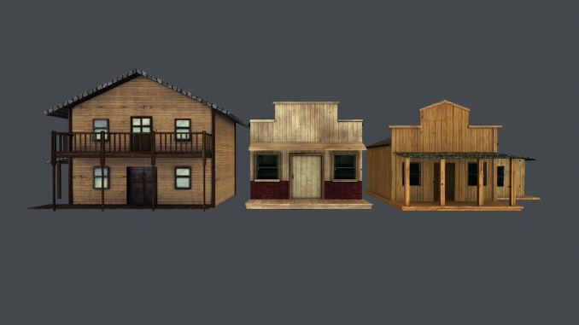  
ninokiboom. (2016). *Western Styled Building Low Poly Game Ready Models - Set of 3 VR / AR / low-poly 3D model.* Available: https://www.cgtrader.com/3d-models/exterior/historic/western-styled-building-low-poly-game-ready-models-set-of-3. Last accessed 17/11/2017.

Examples like these convey a sense of the low poly, aspect that is looking to be achieved. As well as the distance involved in viewing the models making higher poly models less significant by keeping the models to a low poly and texture budget the game will be more fit for the lower processing power of mobile phones over traditional gaming machines (consoles, PC).

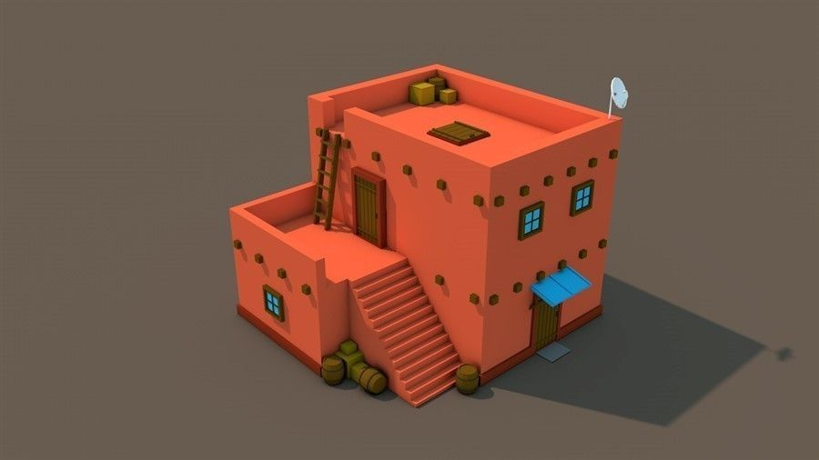  
razrushitel34. (2016). *Low Poly Arab House VR / AR / low-poly 3D model.* Available: https://www.cgtrader.com/3d-models/exterior/house/low-poly-arab-house. Last accessed 17/11/2017.

The textures need not be over complicated for the same reason as having lower poly count models. For these models the textures should not be too intricate but must be bold and contrasting to show any sort of detail at all from the player’s perspective.